Introduction to network devices

Q1. Create a table listing the main functions and typical ports used by switches, routers, hubs, firewalls, and access points in a home WiFi setup
Ans.
Device | Main Function | Typical Ports / Protocols
Switch | Connects multiple wired devices and forwards data using MAC addresses. | Ethernet: 80/443, 22 (management)
Router | Connects the home network to the Internet and routes IP packets. | 80/443, 53 (DNS), 67/68 (DHCP)
HUB | Connects devices and broadcasts data to all connected ports. | Ethernet: No specific network port
Firewall | Monitors and filters incoming/outgoing traffic to protect the network. | 80 (HTTP), 443 (HTTPS), 53 (DNS)
Access Point | Provides Wi-Fi connectivity and connects wireless devices to the wired network. | 802.11 Wi-Fi, 80/443 for management

Note: Physical Ethernet ports (RJ-45) are different from TCP/UDP network ports such as 80, 443, and 53.

Q2. Given images or diagrams of network devices, label each device and mark the ports (Ethernet, console, power, antenna) for at least three devices.
Ans.
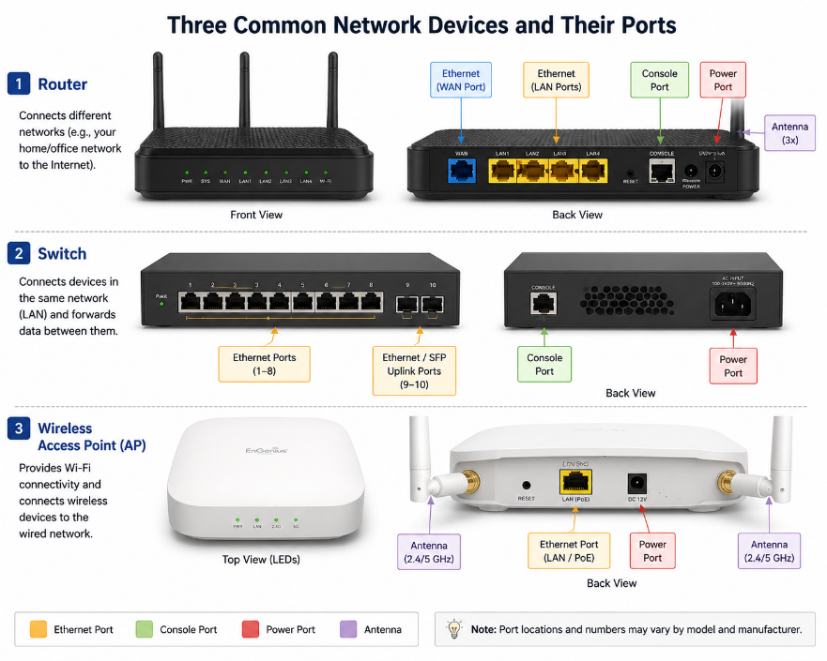

Q3. Pick a popular app you use daily (like Instagram, Zomato, or Paytm) and describe in 3-4 lines how at least two different network devices (from switches, routers, firewalls, access points) play a role when you use that app.
Ans. Example: Instagram
- When I use Instagram, my phone connects to the Access Point (Wi-Fi router) to access the Internet. The Router forwards my data from my home network to Instagram’s servers. A Firewall helps filter and block unwanted or harmful network traffic. Switches in the network also help forward data between servers and other network devices.
Q4. Suppose your college Wi-Fi is slow and sometimes disconnects. Based on the features of access points, switches, and routers, suggest one possible reason for the issue and how upgrading one device could help. Hint: Think about device capacity, coverage, and traffic handling.
Ans. Possible Issue for the slow or un unreliable Wi-Fi Connection are as follows:
- A possible reason is that the Wi-Fi access point is overloaded because too many students are connected at the same time.
- Upgrading to a higher-capacity access point can support more devices and handle more traffic.
- It can also improve Wi-Fi coverage, reducing weak-signal areas and disconnections.
- This would make the college Wi-Fi faster and more stable.

